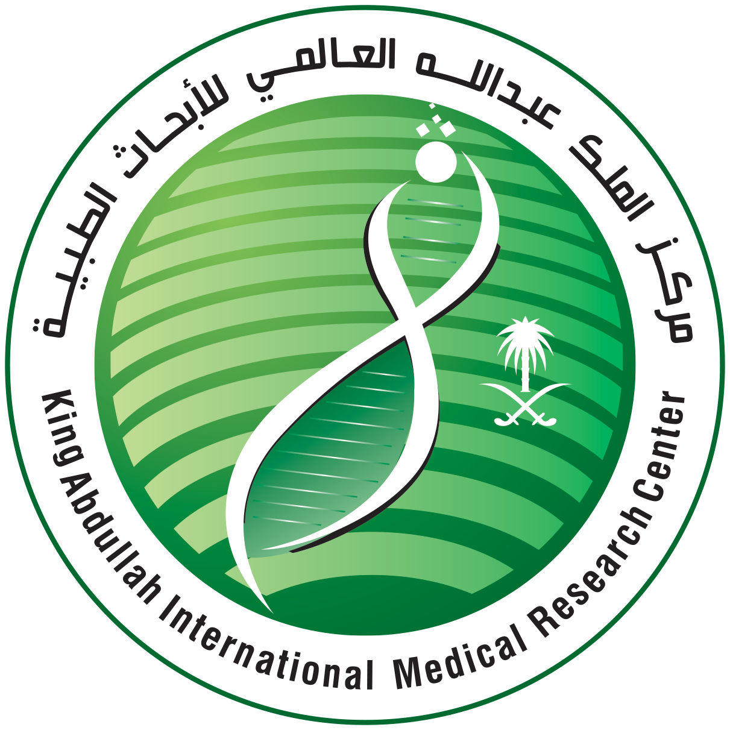

King Abdullah International Medical Research Center
Research Training and Development Section
Ministry of National Guard Health Affairs (MNG-HA)
Kingdom of Saudi Arabia

EDUCATIONAL ACTIVITIES REGISTRATION FORM

INTRODUCTION TO DRUG DISCOVERY – SEPTEMBER 18-19, 2019

PLEASE TYPE OR PRINT CLEARLY AS YOU WANT IT TO APPEAR ON YOUR CERTIFICATE OF ATTENDANCE AND RETURN THE FORM WITH THE PAYMENT.

Position: ____________ _____
Badge No if MNG-HA Staff: ____________ _____

GENDER: Male Female

ATTENDEE INFORMATION (All fields are required)

First Name Middle Name Family Name

Profession/Specialty Saudi Council Reg. No if any Institution & Department

Telephone No. (Including Information Dialing Code) Mobile No

Email Address/ Mail code if MNG-HA employee

Address:

Payment | Registration Fee
Date of Payment: | SR

Important Information:

- Registration is not confirmed until payment is received.
- Payment is accepted in bank transfer.
- Deposit registration fee to:
Account Name: ESC KAIMRC – Main Activity
Account No. 0108005208910345
SWIFT Code: ARNBSARI
IBAN: SA9430400108005208910345
Bank Name: Arab National Bank
Bank Address: Riyadh, Khashmalan Branch 133
- E-mail registration form and copy of your deposit slip to: Email: kaimrc-rtd@ngha.med.sa, kaimrc-rtd1@ngha.med.sa
- Cancellation/Refund Policy:
Administration charge of 20% of the total course fee will be charged in the period up to five (5) days prior to the course commencement date. 100% of the total course fee will be charged within the five-day period prior to the scheduled course commencement date. In exceptional circumstances, as deemed by the Head of Research Training and Development Section, participants will receive a partial refund of the course fee after a meaningful justification.

