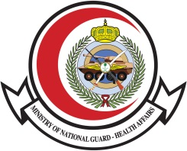

|  |  |  |  |  |
| --- | --- | --- | --- | --- |
| **Time** | **Topic** | **Objectives** | | **Speakers** |
| 9.00 -9.15 | Introduction | | | |
| 9.15-9.45 | Epidemiology of HIV | | Dr.Mohamad BoSaeed | |
| 9.45-10.15 | Natural history and Diagnosis of HIV infection | | DR.Abdulrahman Al Saeedy | |
| 10.15-10.45 | Cases scenarios in AIDS opportunistic infection | | Dr.Ahmad Al Harbi | |
| 10.45-11.00 | Break | | | |
| 11.00-11.30 | Treatment of HIV infection and other opportunistic infection | | Dr. Ibrahim Mahmoad | |
| 11.30-1200 | Antiretroviral drugs overviews (classes, Side Effects and Drug – Drug Interaction) | | Dr.Mohamad Al Essa | |
| 12-12.30 | The emotional aspect and stigmatization | | Dr. Yousra Alatig | |
| 12.30-1300 | Public health role in HIV management | | Ms.Eman Almazroa | |
| 1300-13.05 | closing | | Dr..Majid Al Shamrani | |

**Ministry of National Guard-Health Affairs**

**Infection Prevetnion and Control Program**

**World HIV Day Program**

Date : Sunday, December 12th , 2019

Time : 08:00 a.m. – 01:00 p.m.

Venue : Sammer Bin Huraib large Auditorium