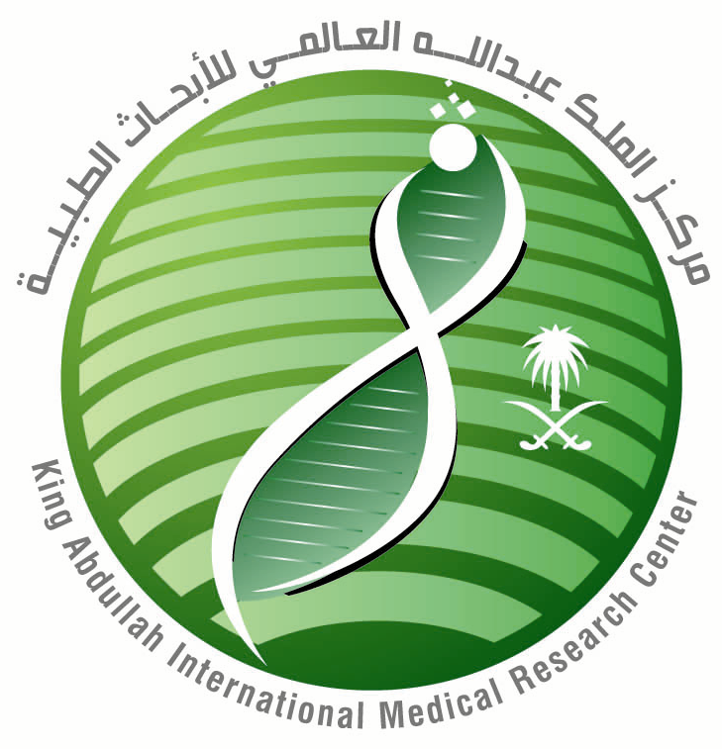Kingdom of Saudi Arabia
National Guard Health Affairs

King Saud bin Abdulaziz University for Health sciences
King Abdullah International Medical Research Center

Application Form (ICH-Good Clinical Practice)

Year: / / 2014

Name:
(First) (Father) (Grandfather) (Last)

Date: ID or Passport #:

Mail Code: Title:

Department Name: Location:

:Position: Specialty

If Yes mention the Date: Did you apply for Research Grand
before?

Are you Principal Investigator? Co-PI?

Employer:

Permanent Address:

Tel # (Home): Work #: Mobile #:

Fax #: E-Mail:

Other Person to Contact: Relation:

Tel # (Home): Work #: Mobile #:

In the near future all Investigators will be required to use NGHA/KAIMRC e-mail addresses.
Please refrain from using any alternative e-mail address here unless it is your only address.
Complete the Registration Form and send soft copy to: gcp_edu@ngha.med.sa.
Confirmation of your registration will be sent to the e-mail address provided.

Signature: Date:

