 | 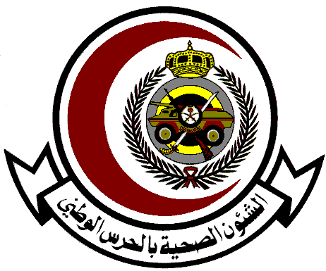 | King Abdullah International Medical Research Centre  Eastern Region  Al Ahsa and Dammam  Ministry of National Guard Health Affairs |  | 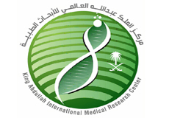
King Abdullah International Medical Research Center - ER   413   (013) 5910000  Ext. 36281/36284 Fax. 36288  Email Add: Mubarakrm@ngha.med.sa |  |  | مركز الملك عبداللة العالمي للأبحاث الطبية-القطاع الشرقي   413   (013) 5910000  تحويلة 36281/36284 3 فاكس 6288

COURSE REGISTRATION FORM

Please print clearly. This will be the name printed on your certificate.

First Name
Middle Name
Last Name
SCFHS
Saudi Council Prof.#

Professional Title:
KANGH Badge No.: |  | Nationality:

Complete Mailing Address:
Hospital:
Department : |  | Mail Code:
P.O. Box : |  | City:
Postal Code : |  | Country:

Contact Numbers (Please include telephone area codes if applicable):

Telephone: |  | Pager:
Fax Number: |  | Mobile Phone:
E-mail:
COURSE TITLE:
COURSE DATE:

Make your payment as a Deposit to the following account number.

Arab National Bank
Account Name: ESC KAIMRC – Main Activity
Account No: 0108005208910345
IBAN: SA9430400108005208910345

